January 21, 2019

Dear {name},

{#items}
{Department}
{Account Code}
{/items}

Thank you for your generous support!
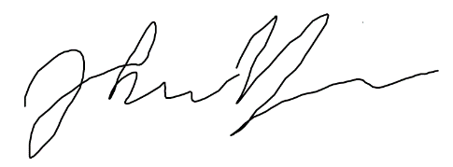
John Yahiro
Treasurer

